វិទ្យាស្ថានបច្ចេកវិទ្យាកម្ពុជា

Institute of Technology of Cambodia

Department of Information and Communication



Subject: Internet Programming

Professor: HOK TIN

Assignment: TP7

Name: LAY Vicha

ID: e20190494

Group: I4-GIC-B

2022-2023

Contents

1. Git url : https://github.com/LAY-VICHA/TP_IP_year4/tree/main/TP6 1

2. EX1 – Activity Suggestion with ExpressJS library 1

3. EX2 – List/viewer with ExpressJS library 2

4. EX3 – Bookstore with ExpressJS library 3

# Git url : https://github.com/LAY-VICHA/TP_IP_year4/tree/main/TP6

# EX1 – Activity Suggestion with ExpressJS library

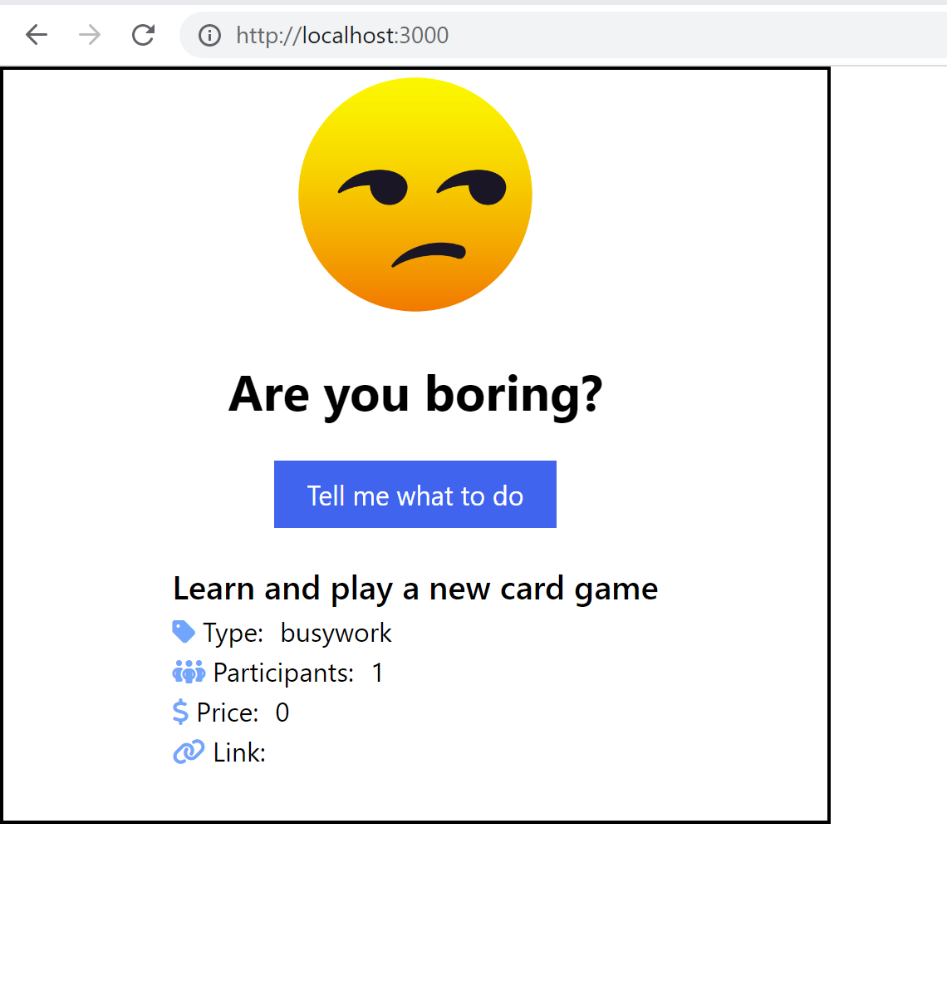

# EX2 – List/viewer with ExpressJS library

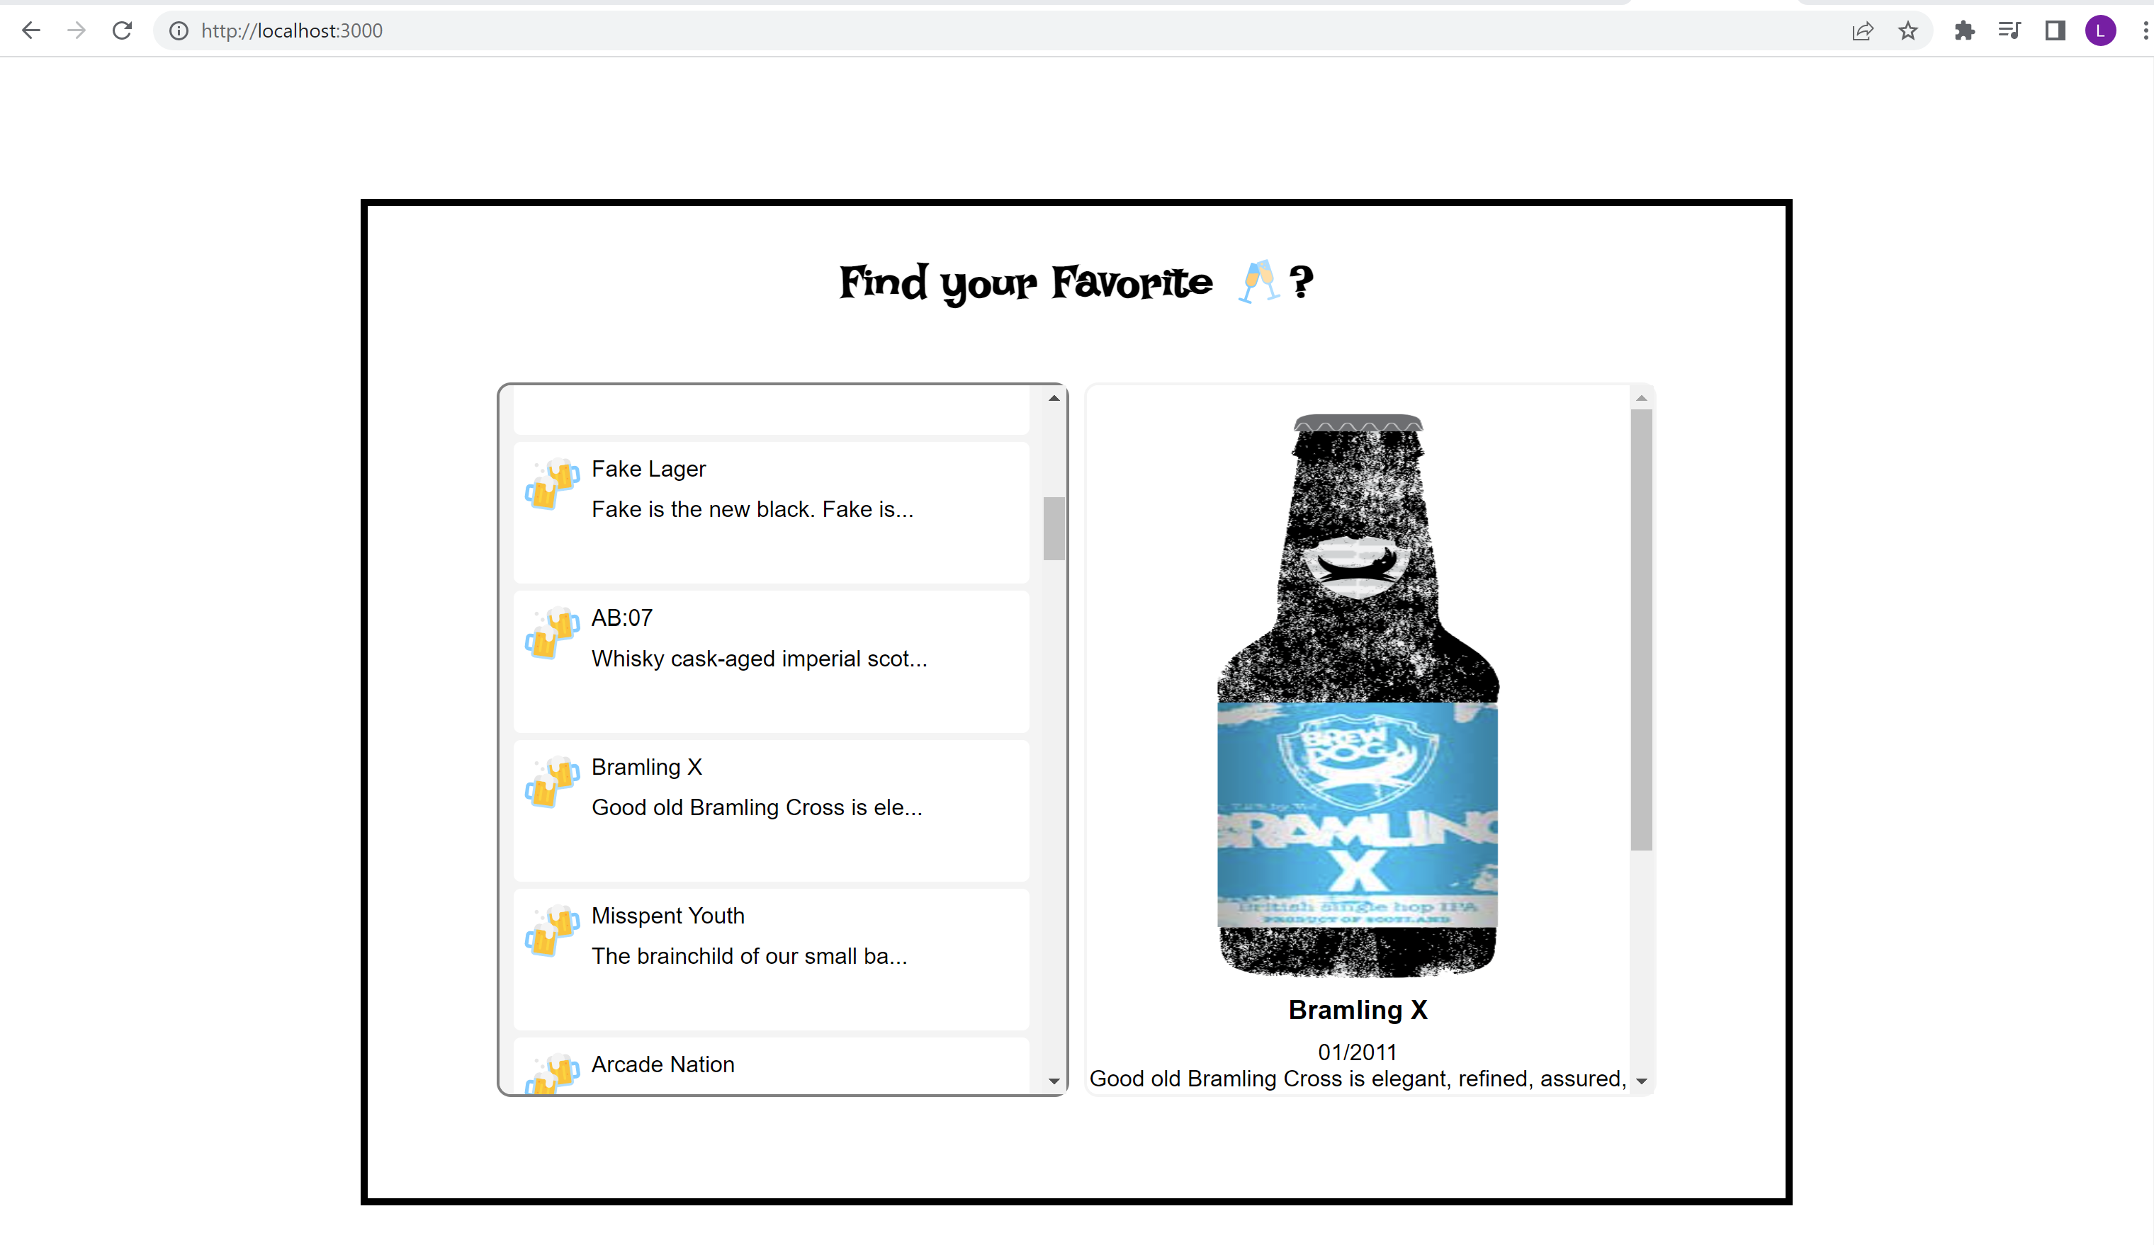

# EX3 – Bookstore with ExpressJS library

